Project Development Phase
Dashboard & Story Screenshots
Heritage Treasures: An In-Depth Analysis of UNESCO World Heritage Sites (2019)
Project Title | Heritage Treasures: An In-Depth Analysis of UNESCO World Heritage Sites (2019)
Domain | Culture & Heritage Analytics / Tourism & Conservation Business Intelligence
Tool | Tableau Desktop / Tableau Public
Dataset | Kaggle UNESCO World Heritage Sites Dataset, 1978–2019 (~1,121 sites, 12 fields)
Prepared By | M. Deepika (Team Lead), M. Supraja, K. Srikala, I. Pushpa, U. Bhavana
Mentor | Not yet assigned
GitHub Repository | https://github.com/mankudeepika123-rgb/Heritage-Treasures-An-In-Depth-Analysis-of-UNESCO-World-Heritage-Sites-2019-
Tableau Public Link | https://public.tableau.com/app/profile/manku.deepika5282/viz/HeritageTreasuresAnIn-DepthAnalysisofUNESCOWorldHeritageSites2019/UNESCOSiteOverviewDangerSitesAnalysis
Date | 22/08/2026

5.2 Dashboard Development
The workbook was assembled into two combined dashboards, each bringing together several chart sheets behind shared filters.

World Heritage Sites Overview Dashboard
Combines Countries per Region, Top 10 Regions by Area (map), Year Forecasting, Categories by Sites Count, and Site Count per Region into a single filterable overview.
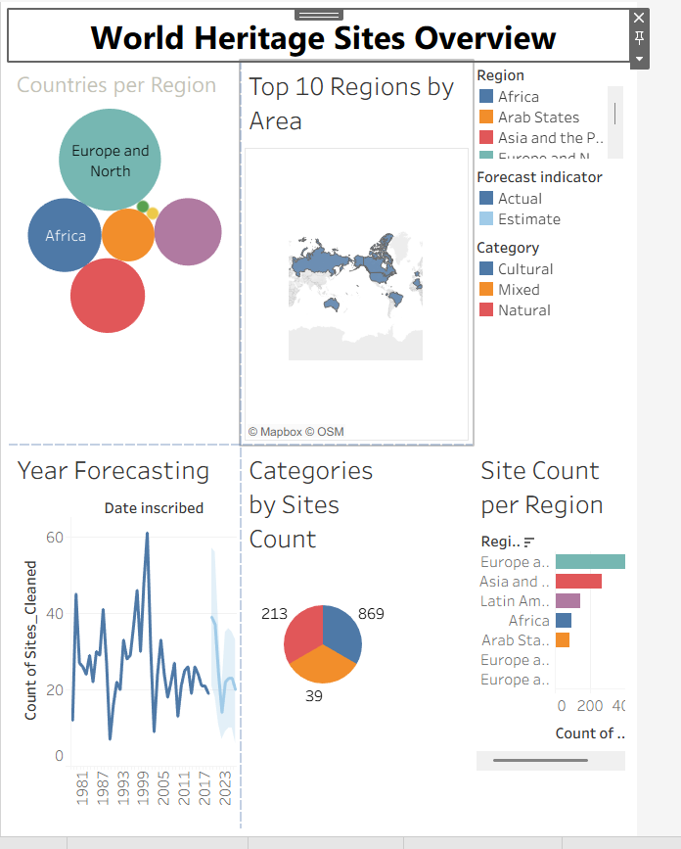
World Heritage Sites Overview — combined dashboard

Danger Sites Overview Dashboard
Combines Regions by Heritage, Top 10 Danger Sites, and Danger vs Area Analysis into a single filterable danger-focused view.
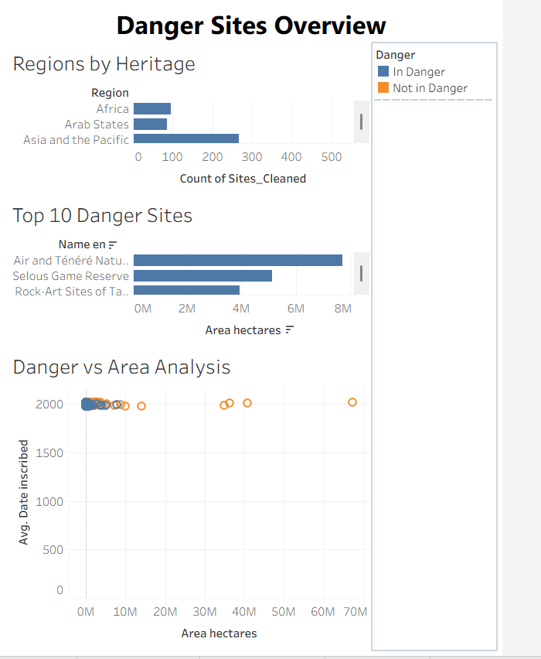
Danger Sites Overview — combined dashboard

5.3 Tableau Story Development
The Tableau Story ‘UNESCO Site Overview, Danger Sites Analysis’ was built with two story points — UNESCO Site Overview and Danger Sites Analysis — each embedding one of the dashboards above with story navigation for the viewer to move between them.
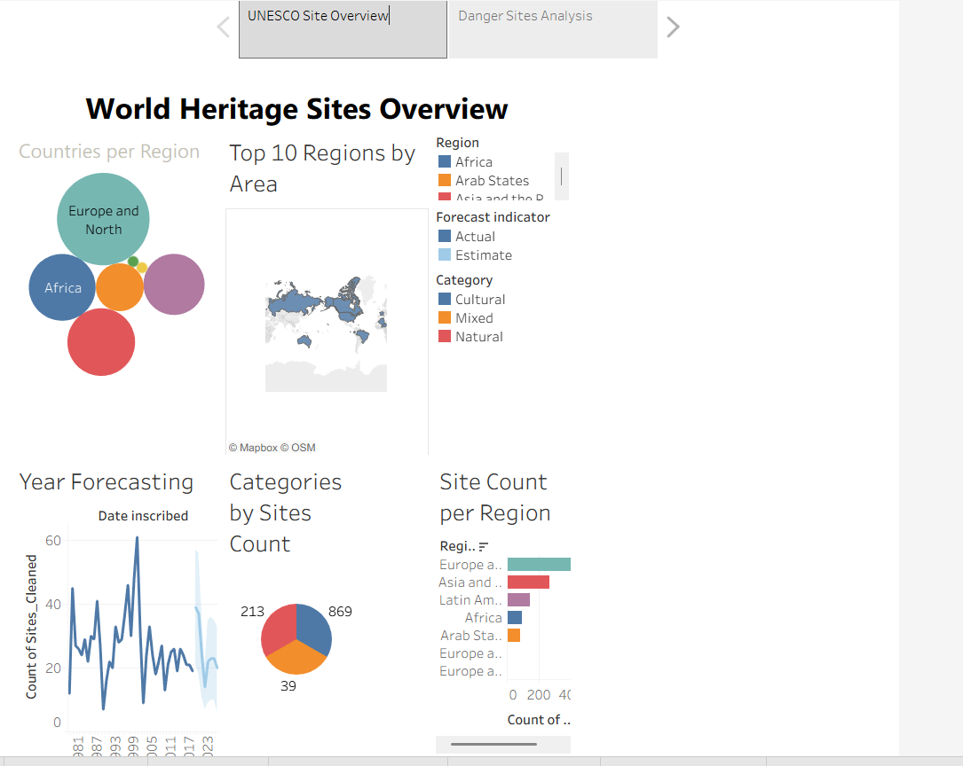
Story Point 1 — UNESCO Site Overview
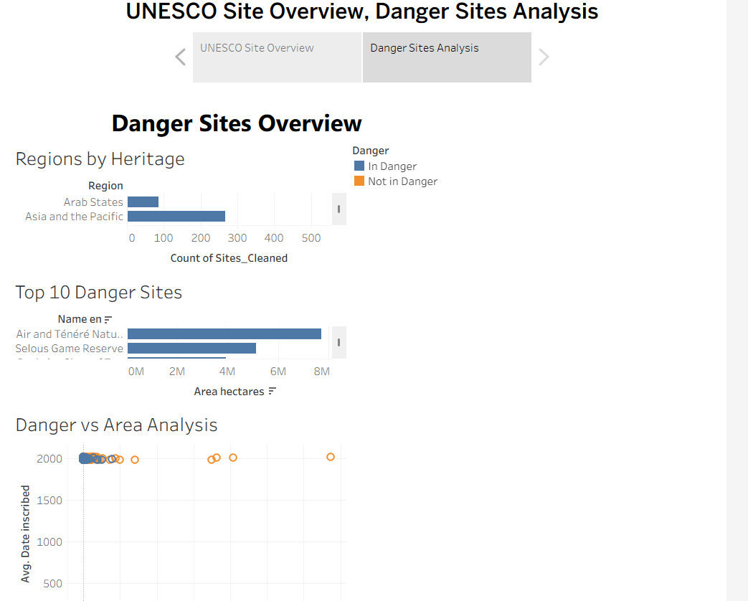
Story Point 2 — Danger Sites Analysis

5.2.1 Supporting Chart Sheets
The individual worksheets behind each dashboard are shown below.
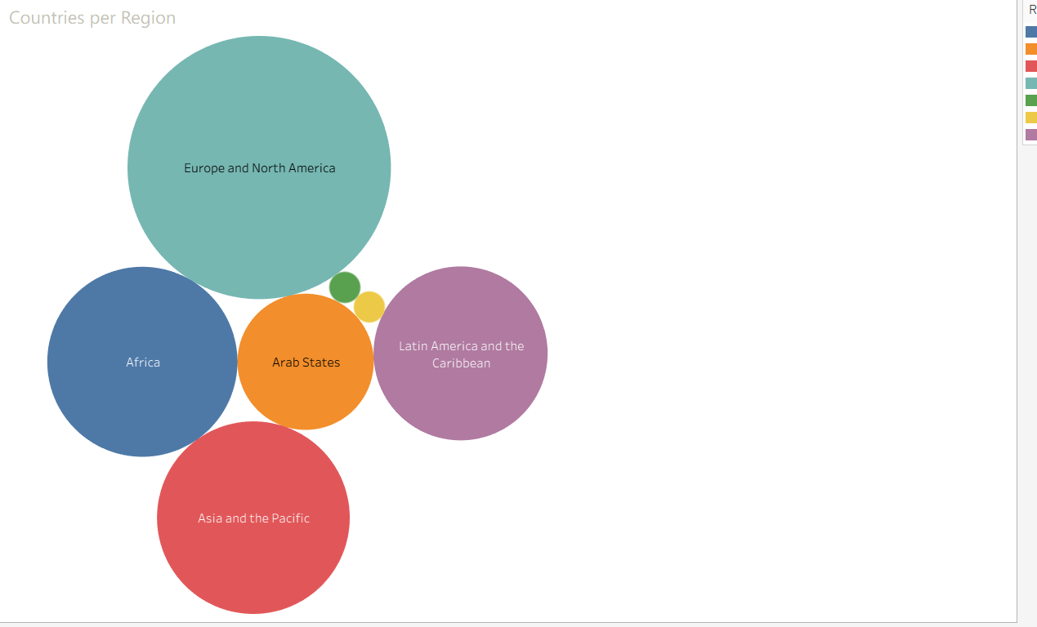
Countries per Region
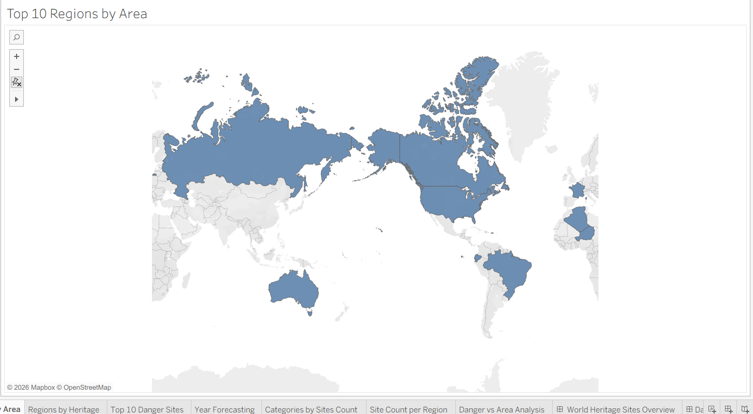
Top 10 Regions by Area
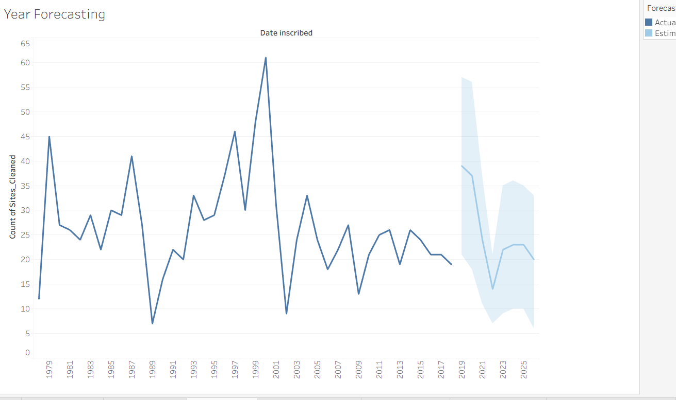
Year Forecasting
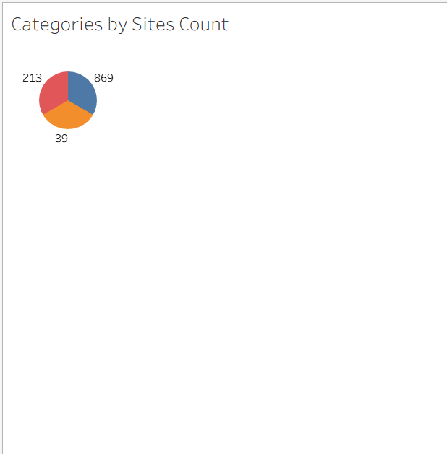
Categories by Sites Count
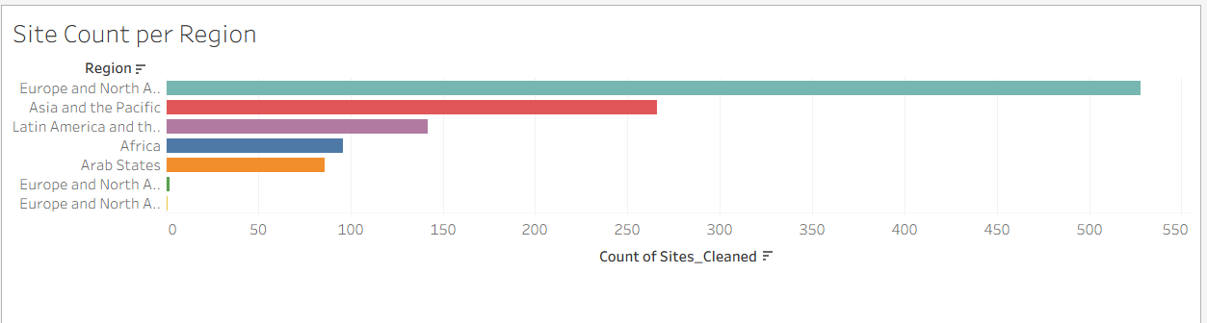
Site Count per Region
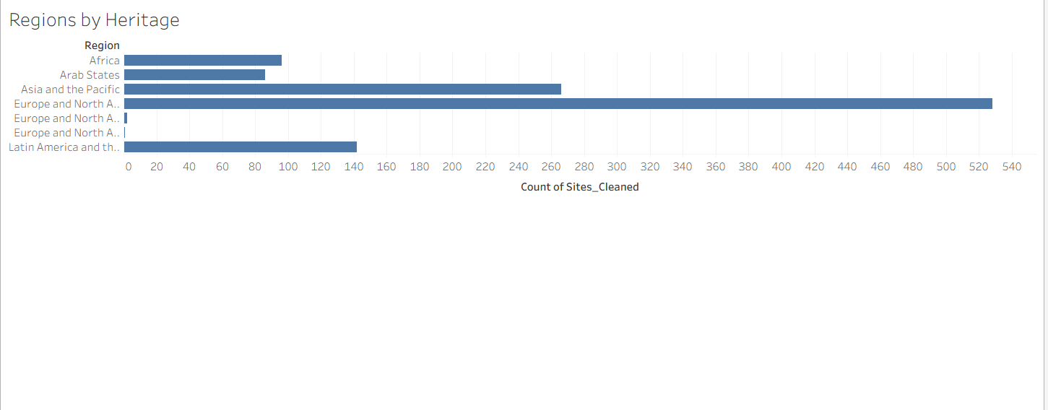
Regions by Heritage
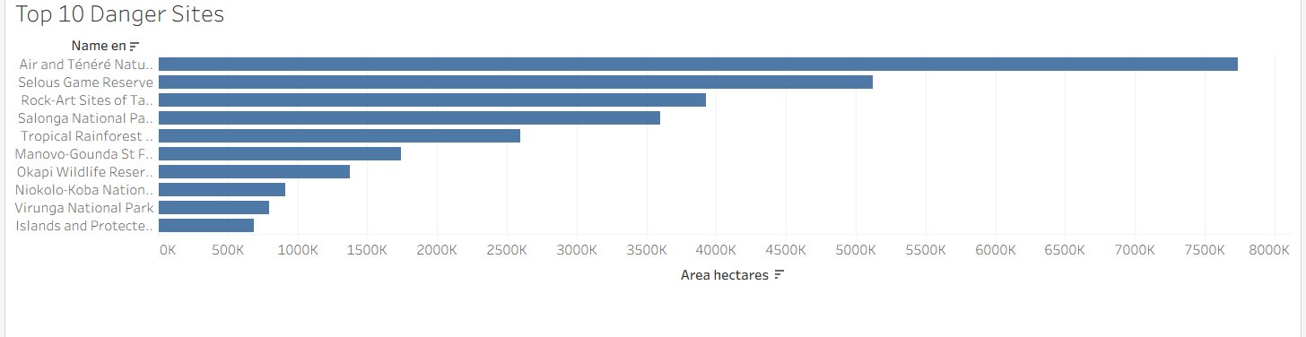
Top 10 Danger Sites
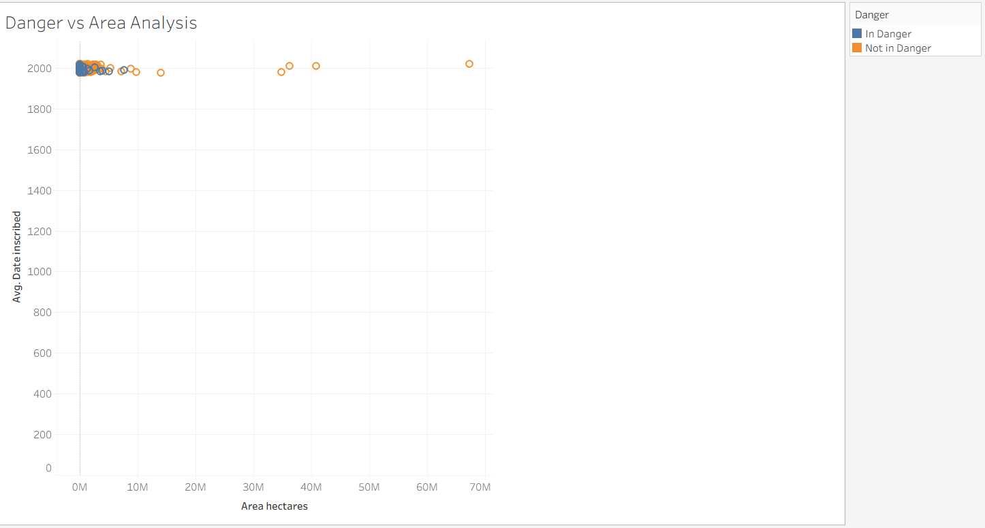
Danger vs Area Analysis

